NORTH DAKOTA LAND SURVEY MONUMENT RECORDS

INTRODUCTION

The United States Public Land Survey System (PLSS) provides the basic boundary control for most of the land in North Dakota. In spite of the relatively crude instruments available and the obstacles to field work at the time that these surveys were done, the system actually has very few weaknesses. Many problems have been created by subsequent surveyors who have not adhered to the rules of procedure for subdivision of sections and for replacement of lost or obliterated corners. Other complications have been caused by the lack of any method of giving official status to aliquot corners set by private surveyors. Perhaps the most serious weakness of the system, however, was the failure to provide any method of perpetuating the original monuments and keeping a current public record of their physical appearance. The Survey and Recordation Act, Chapter 47-20.1 North Dakota Century Code, passed by the 1973 state legislature, provides a method of solving this last mentioned problem. Part of the new method is compulsory; part is permissive. All land surveyors working in North Dakota are required to use the monument record system to preserve the United States Public Land Survey monuments. It is hoped that all land surveyors will use the monument record system to preserve all other monuments, such as non PLSS corners, aliquot section and property corners, control survey stations and benchmarks.

RECORDING INSTRUCTIONS FOR SURVEYORS

COMPULSORY RECORDS

Whenever you conduct a land survey, at least one public land survey corner is used. This corner and any other public land corners used for control of the survey must have a monument record form filed. A public land survey corner of the PLSS includes section corners, quarter corners, sixteenth corners (if set by the original United States Public Land Survey), meander corners, closing corners, witness corners, etc.

Also, if you establish or re-establish any public land survey corner, or restore or rehabilitate any public land survey monument, you must file a corner record form.

If the monument described in the official record no longer exists and is considered Disturbed, Destroyed or Lost and you accept a subsequent monument as marking the position occupied by the original monument, you are in effect restoring an obliterated Lost corner and must file a corner record form explaining the nature of the evidence which led you to accept the monument as valid.
If a metes and bounds survey is simply "tied" to a section corner, quarter corner, or other Government Land Survey control monument, you are required to file a record only on that monument. However, if another public land survey monument was used to establish a basis of bearings, that corner monument must be filed also.
If your survey required the use of several control monuments, each must be reported. Each monument must be reported on a separate monument record form. The mathematical information relating to those corners is encouraged to be shown on the reverse side of the form if room is not available on the front page to show that relationship.

EXAMPLES:

- Miscellaneous tracts.
Two monument records required. Three monument records required.
Angles
given in
description
Parallel

- Subdivision of sections.
Four or more monument records required.

If you establish the center of a section, you will file records for the four quarter corners. If the survey were for the purpose of locating the SE¼, for example, you would also file a record for the SE corner of the section as well as for the four quarter corners. If the SE¼ is to be subdivided into quarters, you must file a record form for all of the monuments shown with a circle in the figure above. You may file a record form for monuments shown with a triangle in the figure above.

- Platted Subdivisions Lot lines within platted and monumented subdivisions will normally be deemed to be controlled by the original or generally accepted block monuments. If it is necessary to start at one or more public land survey monuments to establish or re-establish control within the subdivision, a record must be filed for each such public land survey monument used as control.

EXCEPTIONS TO COMPULSORY RECORDING

The filing of a monument record will not be required if the monument is already filed and the monument and its accessories are substantially as described in the existing monument record.

PERMISSIVE RECORDS

Monument records may be filed on any land survey monument, accessory (including U.S.G.S., N.O.A.A., or BLM monuments when used as accessories or control), or benchmark. Records may be filed pertaining to monuments, accessories, or benchmarks even though they were established, re-established, restored, reconstructed, or rehabilitated before the effective date of the new law, but must be filed if used in a survey of any section of land.

Typical monument records that may be filed include the following:

Center of section

Sixteenth Corners (if not set by the original United States Public Land Survey)

Mineral monuments

Lot, block, subdivision and townsite corners

Corners of miscellaneous tracts and parcels such as metes and bounds survey markers, Sub-Lots, Out-Lot’s, Certificate of Survey’s, Auditors Lot’s, Boundary Survey’s, Deed Retracement Surveys, or any survey requiring control corners.

Judicial corners

N.O.A.A. horizontal and vertical control stations

Benchmarks

TIME LIMIT FOR FILING

In all cases where monument records are required, they must be filed with the Recorders Office in the County where the work is being completed within ninety days of the date on which the monument was used as control or was established, restored or rehabilitated.

FILING FEES

For monument records pertaining to public land survey monuments and their accessories, aliquot corners, or benchmarks, there is a filing fee for each document filed according to the rates established by that Recorder’s office.

REJECTING AN EXISTING MONUMENT

If a public land survey corner is lost or obliterated and a land surveyor places a monument in conformance with the rules and regulations of the U.S. Department of Interior, Bureau of Land Management, as expressed in their current Manual of Surveying Instructions, and is in harmony with the Manual of Practice for Surveying in North Dakota by the NDSPLS as acceptable practice or is in compliance with a decree of a court of law, that monument shall stand as being correct and corner record must be filed.

If it can be proven that the rules were not followed in placing a monument, a new monument is to be placed in the correct position and you must file a new record form explaining the evidence used in determining your position for the corner and rejecting the found monument with reference to distance and direction of the new monument. Before filing a new monument record it is desirable to contact the previous Surveyor you believe to be in error, and compare notes and values used to see if both parties are aware of the differences to seek a resolve to the differences in the situation.

MINIMUM MONUMENT REQUIREMENTS

- Monuments must be a minimum of 1/2" x 18" and ferro-magnetic with a center-punched cap that bears the surveyor's registration number.

- Whenever possible, three reference points should be used.

- Use reference monuments which are dissimilar to corner monument if possible. It is good practice to mark reference monuments so that they are individually identifiable.

- If topographic or planimetric references are used (such as buildings, fence posts, or other physical items on the ground etc.), they should be so noted.

- By law, anyone who disturbs a monument is guilty of an infraction (N.D.C.C. § 47-20.1-12).

DETAILED INSTRUCTIONS FOR ITEMS 1 THROUGH 8
ON MONUMENT RECORD FORMS

It is mandatory that all applicable parts of this form be filled out, if the item is not applicable to the corner, please state that information on the form. If additional space is required it is encouraged use the back side or attach extra sheets to the form.

ITEM 1: TYPE OF CORNER

A corner will always be located in a quarter or Government Lot of some section, township, and range. The first line is used if the corner is part of the Public Land System, such as section corners, quarter corners, closing corners and meander corners. The second line is to be used if the corner is a property corner not part of the Public Land System or for other monuments such as benchmarks.
Monuments recorded on the second line are permissive recordings and are not required to be recorded by law.
The following examples are used to illustrate filling out Item 1:
A public land corner is to be recorded, that is located in the northwest quarter of Section 8, Township 150 North, Range 70 West. The corner is the west ¼ corner of Section 8.

EXAMPLE #1
1. The W ¼ Corner of Section 8 , Township 150 North, Range 70 West of the 5th P.M.

EXAMPLE #2
1. The Corner of Section , Township North, Range West of the 5 P.M.
Or other corner as described The NE corner of Lot No. 1, Block No. 9, Original Townsite or Subdivision Plat, Anytown, North Dakota

ITEM 2: DESCRIPTION OF ORIGINAL MONUMENT

When searching for a monument, it is necessary to know what type of monument to look for (Granite Stone, Lime Stone, Marked Stone, Charred Stake, Iron Post or Pipe, Iron Pin, Brass cap etc.). It is impossible to know if you have found an original monument if you do not know what type of monument was originally set, (monument size and markings).
Notes for the original surveys for the Public Land System are located on the State of North Dakota Web Site Survey Control ND Department of Water Resources http://survey.dwr.nd.gov and at the State Water Commission office in Bismarck, ND.
You can search this site by typing in the Township and Range numbers in the upper right hand corner separating the Township number with a 0, then the Range number. The site will take you right to your search area where you can select to download the GLO plat and or the notes.

Example:
The original General Land Office (GLO) notes call for a granite stone 6”x8”x30” long, firmly set, marked and witnessed as described in the official record.

2. DESCRIPTION OF ORIGINAL MONUMENT (from GLO notes or deed description): Note: If original call is not known, explain.

The corner was monumented by a granite stone 6"x8"x30" long, firmly set, marked and witnessed as described in the official record. Example if 1/4 corner state what side the 1/4 mark is located. If a section corner state the notches.

ITEM 3: DESCRIPTION OF CORNER EVIDENCE FOUND

List pertinent evidence found to substantiate validity of monument position. Include parole evidence (statement by witness) and written records, maps when applicable. Also list any contradictory evidence found. In reporting evidence found, use as precise terminology as possible, e.g.
Use "nominal designation for pipe sizes."
Use standard numbering for deformed rebars.

Iron bars without deformations should be designated as "smooth iron bars/pin".
Tubing is measured by outside diameter.

EXCEPTION: Do not use specific names for rock, wood, or metal unless you are sure of the type; e.g. Calling for a granite stone which is really sandstone, for an oak post which is really maple, or for an iron bar which is really brass will only confuse the issue. In these cases, more general but obvious terms, such as hard, soft, gray, reddish, charred, weathered, etc. will be of more value.

EXAMPLES:
Found 1-1/2" nominal pipe with brass cap marked ^{S4 S3}
S9 S10
in mound of stones with blazed 12" diameter pine, bearing N 27° W, 19.6 ft. and blazed 18" pine, bearing N 63° E, 26.7 ft. Original call was for Granite stone 6"x10"x23" set 12" in ground with mound of stones. Date set July 10, 1879.

- Found rusted 20d nail with weathered red flagging and rotted guard stake lying alongside. Could not trace history of nail. Original call was for 4"x9"x36" granite stone set 24" in ground.
- Interviewed M. J. T. Jones who has lived in a farmhouse approximately 1/4 mile northwesterly of the corner location for the past 47 years. His signed deposition is included under Item 9. Original call was for 4"x4" pine post in mound of dirt with charcoal.
- Found 6"x8"x30" granite stone monument as described in original field notes. Surrounding soil slightly eroded and stone leaning southerly approximately 30° from vertical. Found stump of 8" pine bearing
N 14° E, 28 ft. that may have been bearing tree called for in notes.

3. DESCRIPTION OF CORNER EVIDENCE FOUND:
Also describe the method used to verify or contradict any evidence found.

Found iron pin 12 feet NE of rusted 20d nail with weathered red flag and rotted guard stake lying alongside. Could not trace history of iron pin or nail. Double proportionate measure agrees within 2 feet of 20d nail, but disagrees with iron pin by over 10 feet.

ITEM 4: DESCRIPTION OF METHOD USED TO RESTORE OR RE-ESTABLISH THIS CORNER

If the original monument cannot be found, you will be using some method to determine the location of the corner. The method used should be described in this space. The methods would normally be one of the four listed in Item 4, in which case, you should check the appropriate box. If another method is used, check the “Other” box and explain in the space provided below. It is desirable to mention where the survey notes can be found.
EXAMPLE: The west ¼ corner of Section 8, T-150-N, R-70-W, owners have no knowledge of the corner location, and lines of occupation cannot be determined. Proportionate measure is the only method left. Describe the control corners used in the proportion of this corner.
Original recorded distance was 80 chains between Northwest and Southwest section corners.
You measured 5282.0 feet between the found corner monuments (or 2 feet long).
Original distance measured between northwest section corner and the west ¼ corner is 40 chains; therefore, the west ¼ corner would be placed at mid-point, 2641.0 feet from the Northwest and 2641 from Southwest section corners on line between the two corners.

4. DESCRIPTION OF METHOD USED TO RESTORE OR RE-ESTABLISH THIS CORNER.
❑ Measure from accessories, ❑ Testimony, ❑ Lines of occupation, or ❑ Proportionate measure from other corners.
❑ Other (Explain below )

Adjoining owners have no knowledge of the corner location and the lines of occupation cannot be determined Proportionate measure was used. Original distance measured between northwest section corner and the west ¼ corner is 40 chains; therefore, the west ¼ corner would be located 2641.0 feet from the northwest section corner. The overall distance between section corners is 5282.0 feet and record distance is 80 chains. The retracement survey Field notes for this project are on file in Stone Surveying office in Anytown, North Dakota.

ITEM 5: SKETCH SHOWING MONUMENTATION

Make a neat sketch showing the relative positions of the monument and reference points. Give dimensions with appropriate degree of precision; state basis of bearings; give scale of drawing if possible. Show both supporting and contradicting evidence. The Survey Crew Leader or Supervisor should sign and indicate the date of the survey on the lines provided.

EXAMPLE 1

- SKETCH SHOWING MONUMENTATION:
Describe accessories, dimension a minimum of three permanent ties to the corner, show distances to and the angles between adjacent corners.
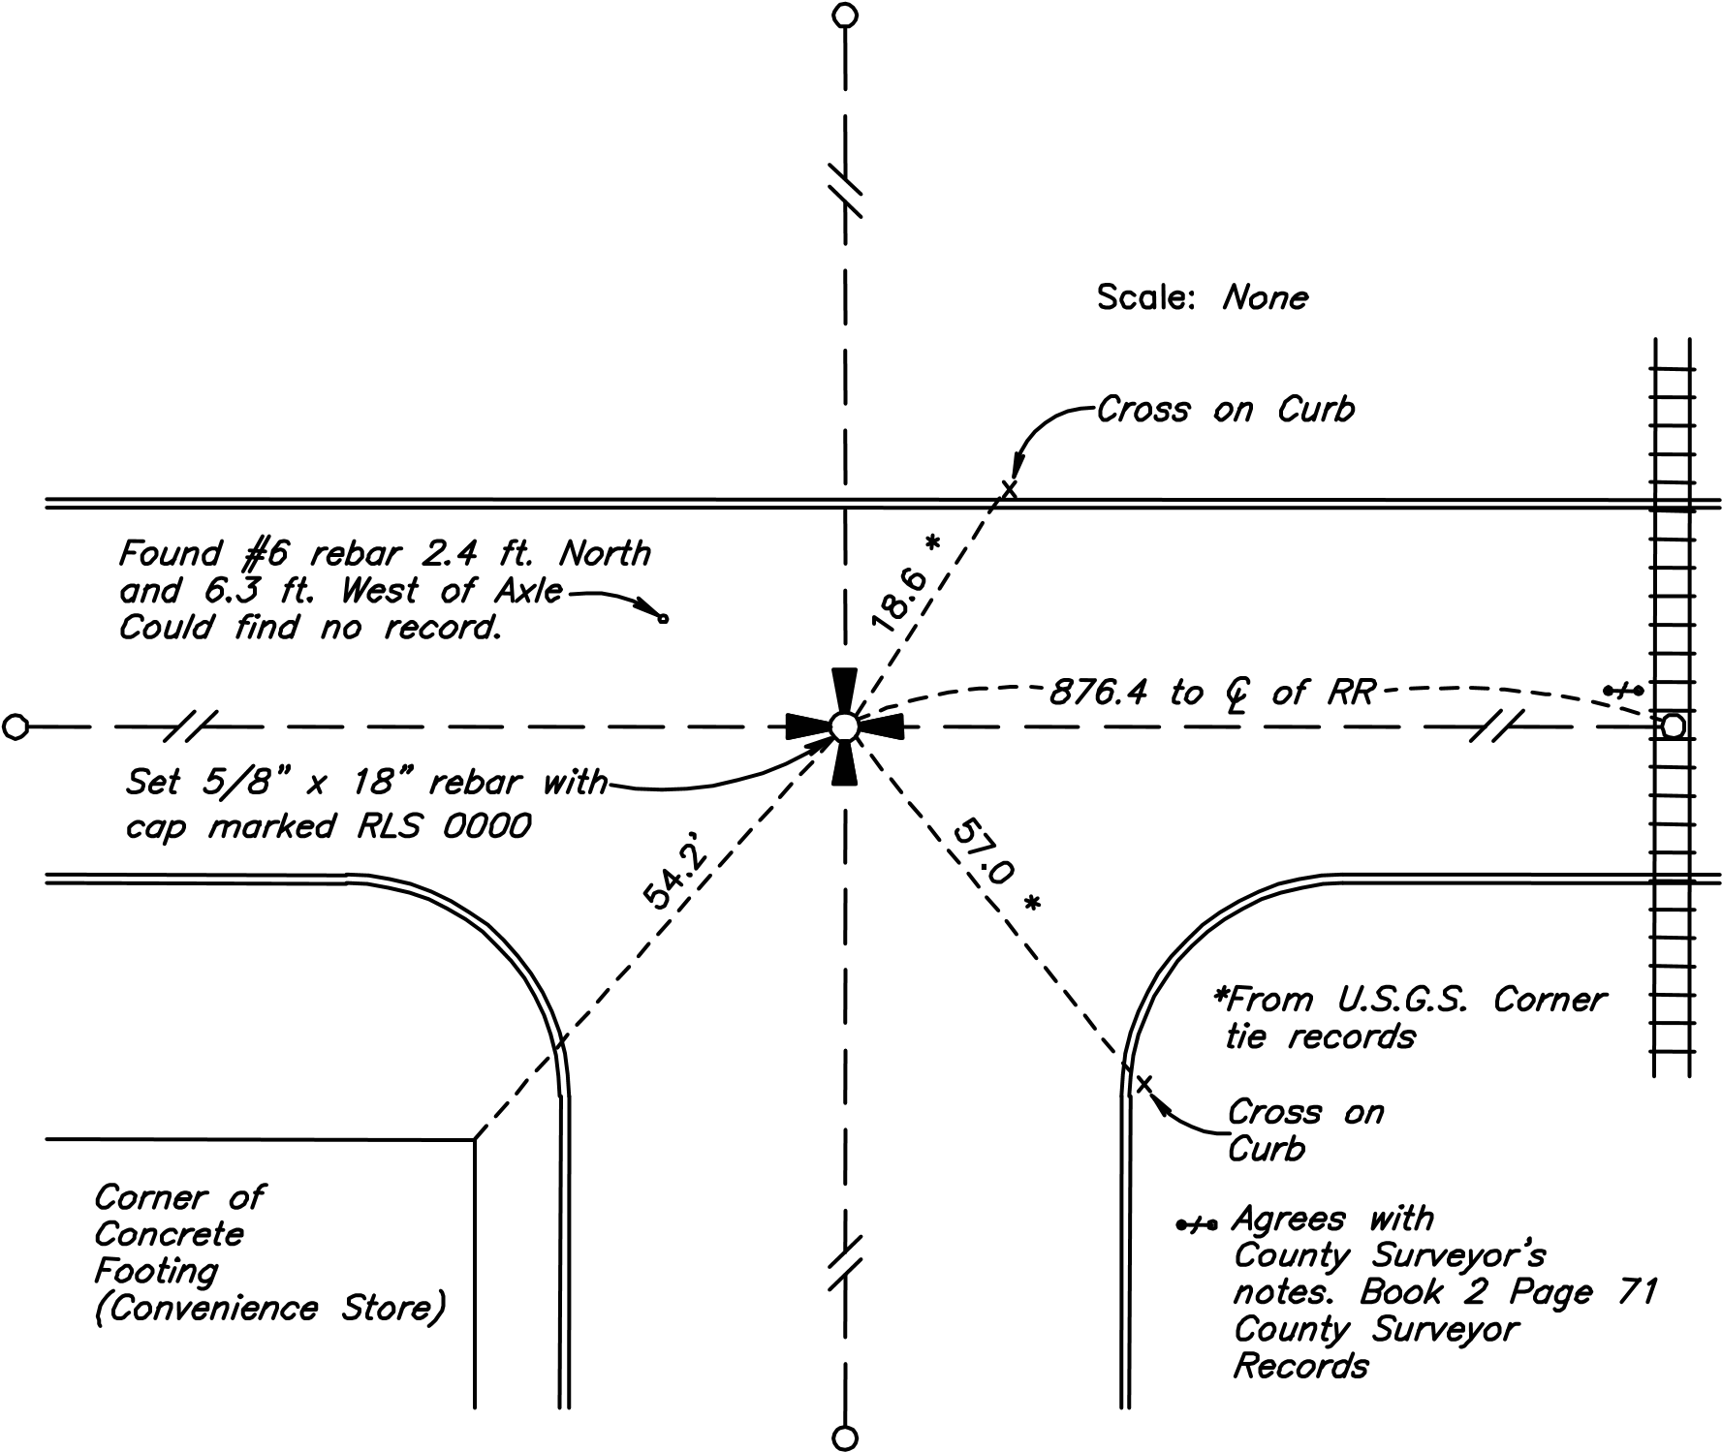

EXAMPLE 2

5. SKETCH SHOWING MONUMENTATION:
Describe accessories, dimension a minimum of three permanent ties to the corner, show distances to and the angles between adjacent corners.
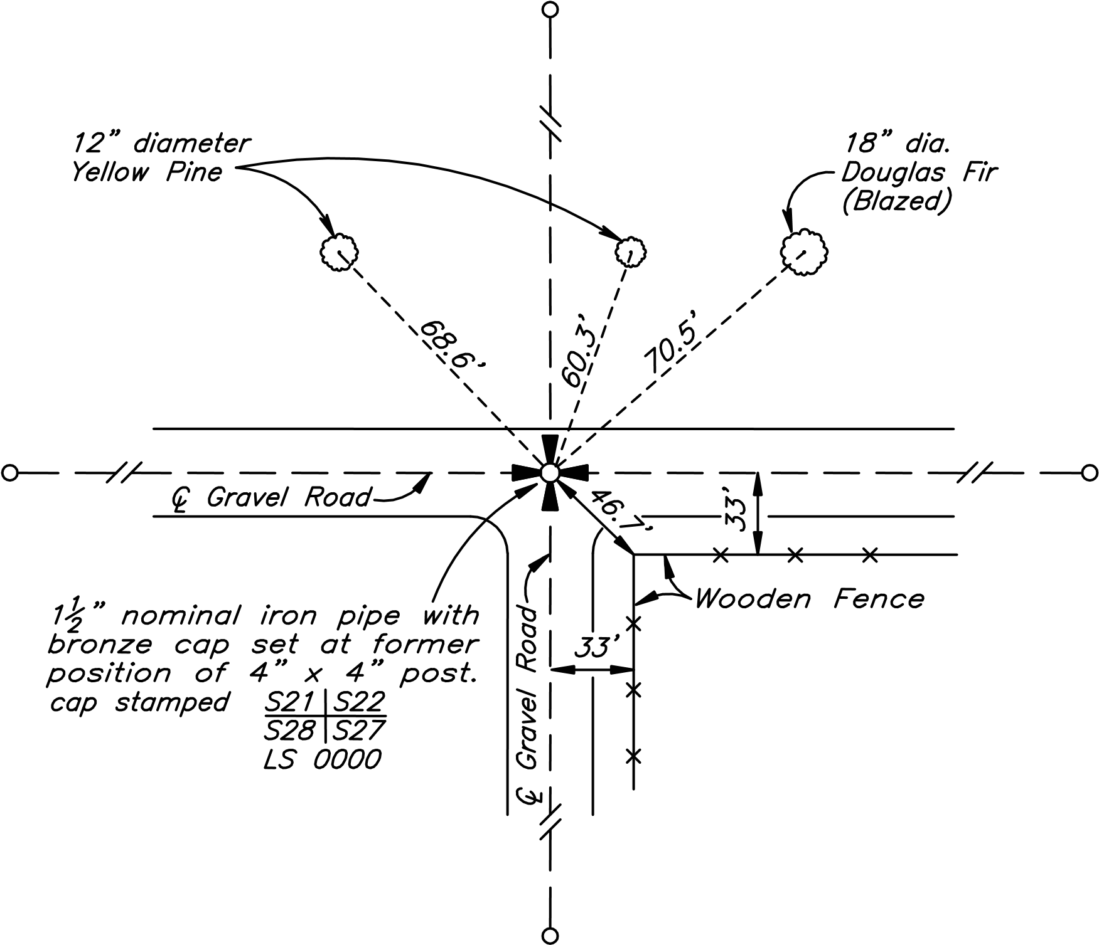
I hereby certify that I have for 47 years resided in the vicinity of the corner common to sections 21, 22, 27, 28 and on many occasions prior to 1938 saw a weathered 4"x4" post in the position shown on the adjacent sketch.

(Signed) _______________________________________ Date:____________

ITEM 6: CERTIFICATION
Indicate the date that the monument was established, re-established, restored, reconstructed or rehabilitated by you or the date the monument was used by you as control. If the field work was done by a party chief, they must sign in the space provided.
Registered land surveyors must sign and seal in the space provided. Signature must cross the face of the Seal, and may be either impression type or rubber stamp, but rubber stamp (and black ink) is preferred.

- CERTIFICATION:
I hereby certify that under the requirements of N.D.C.C. 47-20.1 and the rules defined by NDCC 43-19.1-02, subsection 8 this corner record correctly represents work performed by me or under my direct supervision and is in compliance with the survey standards of NDSPLS MANUAL OF PRACTICE FOR LAND SURVEYING IN NORTH DAKOTA and the approved methods for corner restoration and section breakdowns by the current BLM “MANUAL OF SURVEYING INSTRUCTIONS”.

APPROVED AND SIGNED BY: John Jones ND LS NO. 0000 DATE: 8/1/2021

Surveyor's Seal Date of Survey and Party Chief Signature block

______________________________________
Date of Survey

__________________________________
Survey Crew Leader

ITEM 7: SECTION AND INDEX CODE DIAGRAMS

EXAMPLE: The northwest section corner of Section 18, T-150-N, R-70-W is to be recorded.

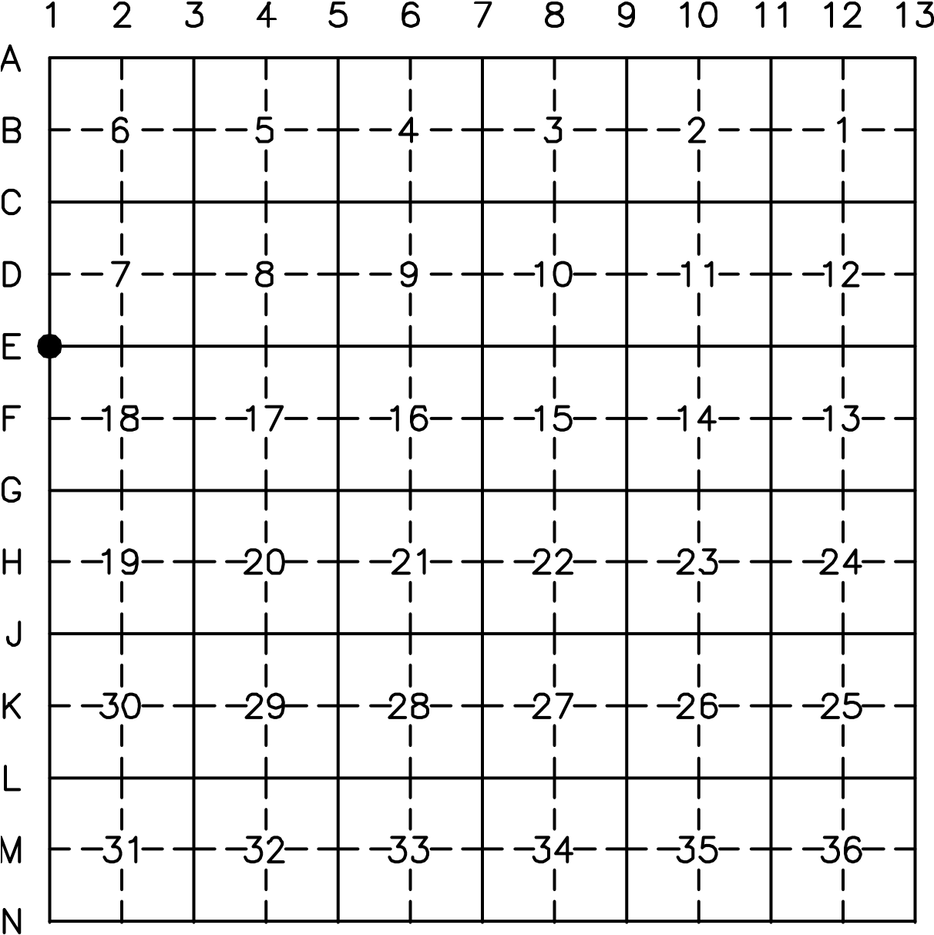

ITEM 8: LOCATION

Show township name and index reference number. The index number is to start with the number and then the letter.

EXAMPLE: The corner is placed on the township line. Indicate both townships in which the corner can be found. The index numbers would be 1-E and 13-E, Not E-1 and E-13.

NW corner Section 18, T150N. R70W , Index Ref. No.1-E,
NE corner Section 13, T150N. R71W. Index Ref. No. 13-E_

EFFECTS OF NON-COMPLIANCE

All North Dakota registered land surveyors who shall willfully or knowingly violate any of the provisions of the law relating to the filing of monument records, may be liable to misconduct charges which shall constitute grounds for revocation of the surveyor's registration. Such a person shall be entitled to a hearing on the action for revocation as prescribed by Chapter 43-19.1 N.D.C.C.

Adopted by the North Dakota State Board of Registration for Professional Engineers and Land Surveyors on September 5, 1997.
Effective date: January 1, 1998
Adopted by NDBoR March 2, 2022

