**NORTH DAKOTA LAND SURVEY MONUMENT RECORD**

(Report only one monument per form)

1. The PLSS ______ Corner of Section ______, Township ______ North, Range _______ West, of the 5th P.M.

Or other corner as described

2. DESCRIPTION OF ORIGINAL MONUMENT: (From original GLO records and any subsequent records).

3. DESCRIPTION OF CORNER EVIDENCE FOUND IN DETAIL INCLUDING ACCESSORIES:

Explain the verification or contradiction of that evidence for the corner.

4. DESCRIPTION OF METHOD USED TO RESTORE, RE-ESTABLISH OR REHABILITATE THIS CORNER:

Measure from accessories Testimony Lines of occupation, or Proportionate measure from other corners indicating those corners used in that process, and the distances and direction from those corners, Other (explain below) A sketch on reverse side of this form for additional information is encouraged to show the restoration values.

5. SKETCH SHOWING MONUMENTATION OF THE CORNER AND WHAT WAS SET IN DETAIL AND ALL THE ACCESSORIES TO REFERENCE THE MONUMENT: (At least 3 permanent ties to the corner) List Coordinates, type of the corner monument if determined along with Reference Frame, Zone, Datum, WGS84 Latitude/Longitude or origin.

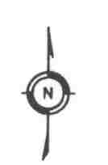

Coordinate list

N**_________________**

E_________________

Z**_________________**

__________________

Date of Survey

**__________________** Party Chief

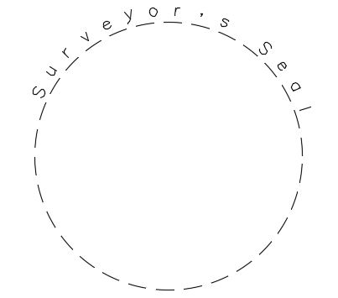

6. CERTIFICATION: I hereby certify that under the requirements of NDCC 47-20.1, SURVEY AND CORNER RECORDATION ACT and NDCC 43-19.1-02, subsection 8, this corner correctly represents work performed by me or under my direct supervision and is in compliance with the survey standards of NDSPLS MANUAL OF PRACTICE FOR LAND SURVEYING IN NORTH DAKOTA and the approved methods for corner restoration and section breakdowns by the current BLM “MANUAL OF SURVEYING INSTRUCTIONS”.

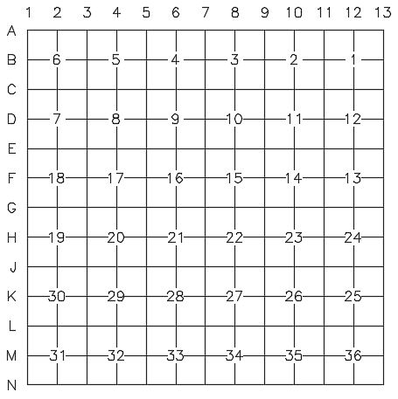DATE: APPROVED AND SIGNED BY , ND PLS NO.

7.

ACCEPTED FOR FILING

Record to be filed by index Reference Number, Numerically, then

Alphabetically under appropriate Township, Range.

8. Section ____ Township Range _______ Index Ref. No. _________ County _______________ 8a. Section ____ Township ________ Range _______ Index Ref. No. _________ County _______________