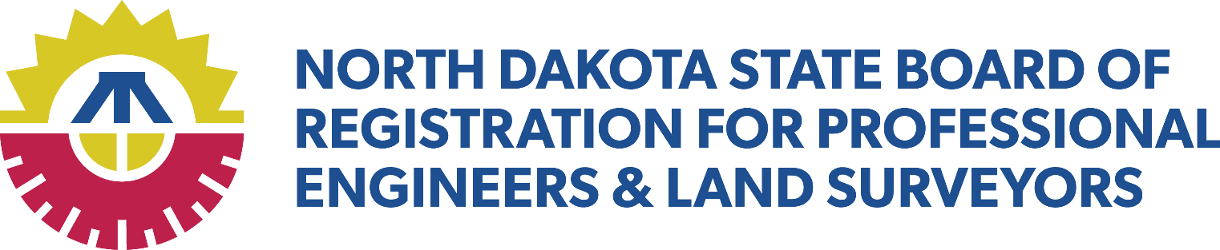
BOARD MEETING AGENDA
September 30, 2026 – 10:00 a.m.
Board Conference Room
3255 Greensboro Drive, Suite 203, Bismarck, ND 58503
Zoom: https://zoom.us/j/98498720106 Meeting ID: 984 9872 0106

- Opening Remarks
- Roll Call
- Introduction of Guests

- Old Business
  - Responsible AI Usage
  - NCEES Foundation/Scholarship Funding
  - Fraudulent Seals

- Future Meetings and Events
- October 7, 2026, 1:00 p.m., NCEES State of the Council Meeting, Remote
- October 11-13, ABET State Board Observer, NDSU, Fargo (Beck)
- October 18-20, ABET State Board Observer, Univ of Jamestown, Jamestown (Ballinger)
- October 22, 2026, 8:00-5:00, AG Professional Licensing Board Training Seminar, Capitol/Remote
- October 28, 2026, 9:00 a.m., Board Meeting, Board Conference Room
- December 9, 2026, 9:00 a.m., Board Meeting, Board Conference Room
- January 27, 2027, 9:00 a.m., Board Meeting, Board Conference Room
- March 10, 2027, 9:00 a.m., Board Meeting, Board Conference Room
- April 19-20, 2027, 12:00 p.m., NDSPE Annual Meeting, Courtyard by Marriot, Bismarck
- April 22-24, 2027, All Zone Meeting, Omaha, NE
- April 28, 2027, 9:00 a.m., Board Meeting, Board Conference Room
- June 2, 2027, 9:00 a.m., Board Meeting, Board Conference Room
- July 21, 2027, 10:30 a.m. Board Meeting, TBD Fargo
- July 21, 2027, 5:30 p.m., Annual Banquet, TBD Fargo
- August 17-20, 2027, NCEES Annual Meeting, Verona, NY
- August 22-25, 2028, NCEES Annual Meeting, Kansas City, MO

- Closing Comments and Adjournment

